Database Management System

🧠 What Is a Database Management System (DBMS)?
# Source: AI Source: Provided by: [Data Path: Persons Table -> ID Column: 1, Name_En Column: Motasem Essam] -> From: [ChatGPT] on [6/10/2026]
A Database Management System (DBMS) is software that allows you to store, organize, retrieve, and manage data in a structured way.
It acts as a bridge between the raw data and the user or application that needs to access that data.

🔑 Key Functions of a DBMS
# Source: AI Source: Provided by: [Data Path: Persons Table -> ID Column: 1, Name_En Column: Motasem Essam] -> From: [ChatGPT] on [6/10/2026]
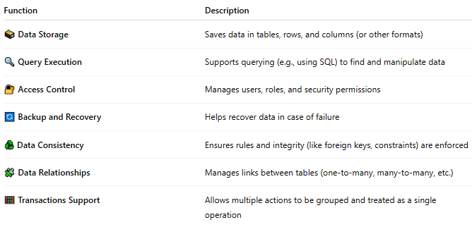
Function | Description
🗃️ Data Storage | Saves data in tables, rows, and columns (or other formats)
🔍 Query Execution | Supports querying (e.g., using SQL) to find and manipulate data
🔐 Access Control | Manages users, roles, and security permissions
🔄 Backup and Recovery | Helps recover data in case of failure
♻️ Data Consistency | Ensures rules and integrity (like foreign keys, constraints) are enforced
🧩 Data Relationships | Manages links between tables (one-to-many, many-to-many, etc.)
🧮 Transactions Support | Allows multiple actions to be grouped and treated as a single operation

📦 Common Examples of DBMSs
# Source: AI Source: Provided by: [Data Path: Persons Table -> ID Column: 1, Name_En Column: Motasem Essam] -> From: [ChatGPT] on [6/10/2026]
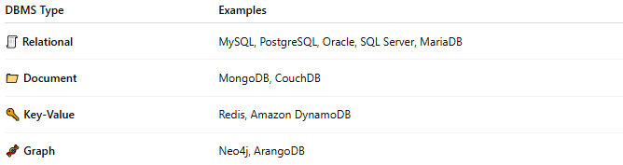
DBMS Type | Examples
🧾 Relational | MySQL, PostgreSQL, Oracle, SQL Server, MariaDB
📁 Document | MongoDB, CouchDB
🔑 Key-Value | Redis, Amazon DynamoDB
🧬 Graph | Neo4j, ArangoDB

🧱 DBMS vs. Database
# Source: AI Source: Provided by: [Data Path: Persons Table -> ID Column: 1, Name_En Column: Motasem Essam] -> From: [ChatGPT] on [6/10/2026]
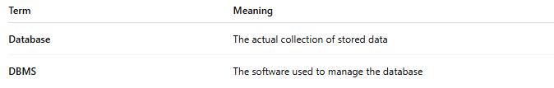
Term | Meaning
Database | The actual collection of stored data
DBMS | The software used to manage the database

🧪 Example in Practice
# Source: AI Source: Provided by: [Data Path: Persons Table -> ID Column: 1, Name_En Column: Motasem Essam] -> From: [ChatGPT] on [6/10/2026]
Let’s say you have a website that stores customer orders.
- The database contains tables like Customers, Orders, Products
- The DBMS (e.g., MySQL) handles:
  - Saving new orders
  - Retrieving customer data
  - Ensuring two orders don’t overwrite each other
  - Allowing admins to run reports

🧭 Types of DBMSs
# Source: AI Source: Provided by: [Data Path: Persons Table -> ID Column: 1, Name_En Column: Motasem Essam] -> From: [ChatGPT] on [6/10/2026]
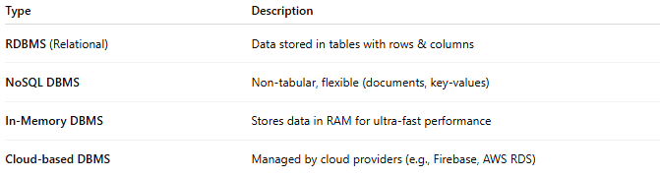
Type | Description
RDBMS (Relational) | Data stored in tables with rows & columns
NoSQL DBMS | Non-tabular, flexible (documents, key-values)
In-Memory DBMS | Stores data in RAM for ultra-fast performance
Cloud-based DBMS | Managed by cloud providers (e.g., Firebase, AWS RDS)

📌 Summary
# Source: AI Source: Provided by: [Data Path: Persons Table -> ID Column: 1, Name_En Column: Motasem Essam] -> From: [ChatGPT] on [6/10/2026]
A DBMS is essential software that makes storing and working with large amounts of structured data safe, efficient, and organized.

